Key outcome name: Freshwater for in-Delta uses
Authors: James Gilbert^{1,2*}, Dino Bellugi³, Abhinav Sharma¹, Khandaker Iftikhar Islam¹

*Corresponding author: James Gilbert, james.gilbert@ucsc.edu

¹ University of California, Santa Cruz, Institute of Marine Sciences’ Fisheries Collaborative Program, 1156 High Street, Santa Cruz, California 95064, U.S.A.
² Fisheries Ecology Division, Southwest Fisheries Science Center, National Marine Fisheries Service, National Oceanic and Atmospheric Administration, 110 McAllister Way, Santa Cruz, California, 95060, U.S.A.
³ University of California, Berkeley, Department of Environmental Science, Policy and Management, 130 Mulford Hall #3114, Berkeley, CA 94720-3114

Background
Over the past 150 years, the Sacramento-San Joaquin Delta has been modified and managed to support farming on Delta islands and the conveyance of freshwater from upstream tributaries to pumps and diverters throughout the region. A key part of Delta management is balancing freshwater inflows, local consumptive uses, outflows, and export pumping to prevent an increase in the salinity of Delta waters that would be detrimental to irrigation and potable use. We include a key outcome metric that tracks this salinity management because of the direct impact that saline water can have on important local uses.
The interactions between flows, uses, and salinity in the Delta are represented in the CalSim3 model via operating rules that act on and respond to estimated salinity at different locations. Salinity is estimated using an artificial neural network (ANN) that emulates the flow-salinity dynamics as captured by the 1-D hydrodynamic model DSM2. Among the locations for which salinity conditions are emulated in CalSim3 are two compliance points in the western Delta: Emmaton (on the Sacramento River) and Jersey Point (on the San Joaquin River). The salinity at these locations integrates the effects of tributary inflows and water use activities in much of the Delta and thus provide useful indicators of salinity conditions in Delta waterways.
The outcome level designation for in-Delta water uses seeks to assign a numerical value to indicate how frequently and by what magnitude the salinity in the key Delta waterways is sufficiently fresh for human potable consumption and/or agricultural use. The outcome level formulation combines three salinity thresholds (expressed as electrical conductivity, in units of microSiemens/cm) and a count of how often each threshold is exceeded at each station as the basis for the outcome level value assignment. The thresholds are based on a combination of State Water Resources Control Board (SWRCB) benchmarks for drinking water quality (California State Water Resources Control Board, 2017) and approximate economic and agronomic response to salinity in irrigation water (Medellín-Azuara et al., 2014).
The lowest threshold (900 uS/cm) represents the boundary for recommended freshwater quality – less than 900 uS/cm electrical conductivity reflects preferred freshwater conditions for all uses, greater than 900 uS/cm reflects water that is still usable but trending towards less desirability. The middle threshold of 1600 uS/cm corresponds to the upper limit of SWRCB allowed long-term salinity conditions and, in comparison to the 900 uS/cm, reflects a range of increasingly salty water that may be less desirably, but is still usable. Irrigation water in this range may present some issues for salt-sensitive crops. The upper limit of 2500 uS/cm represents a salinity level that is no longer recommended for drinking water and begins to impair crop condition when used for irrigation.
The outcome level formulation assumes that small or infrequent excursions of higher salinity are manageable and not sufficient to move the designation to the next lower (worse) value. Rather, outcome level designations are based on whether simulated salinity values are below the lower or middle threshold most of the time, with allowances for being above the highest standard more rarely. We use the entire CalSim3 simulation time series (i.e. 1200 monthly values) to evaluate salinity conditions so that the frequency of high and low salinity occurrence reflects the within-year and between-year variation in salinity. Episodes in which salinity thresholds are exceeded will most often correspond to late summer and fall months and drought periods. Thus the outcome level will reflect how reliably water management actions in a scenario provide flexibility for fresh tributary inflows during these critical periods.

Locations of Interest
The outcome level calculation is based on the simulated salinity time series (expressed as conductivity) at two compliance locations estimated within the CalSim3 Delta ANN: Emmaton and Jersey Point. The locations of these stations are shown on the map in Figure 1 (below). The CalSim3 variable names used for the data extraction and calculations are EM_EC_MONTH/SALINITY/ (Emmaton) and /JP_EC_MONTH/SALINITY/ (Jersey Point), both in the native units of umhos/cm (equivalent to uS/cm).
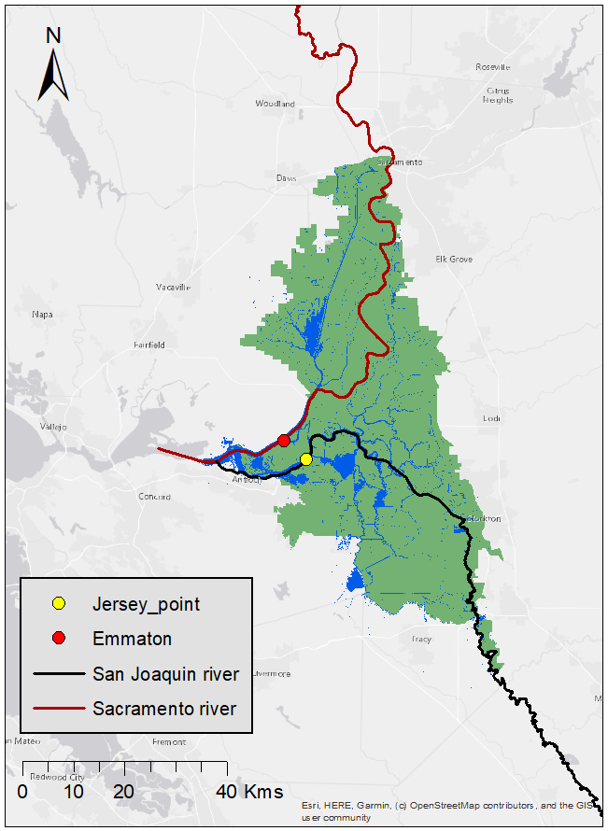
Figure 1. Map of Sacramento-San Joaquin Delta with two in-Delta salinity compliance locations. The Jersey Point station (yellow) is located on the San Joaquin River while the Emmaton station (red) sits on the Sacramento River.

Methodology
Outcome levels reflect the frequency with which water in the western Delta falls into fresh, moderate, or saline categories as an indicator of its suitability for in-Delta uses. Outcome levels are defined based on the frequency with which two west-Delta salinity stations (Emmaton [EM], Jersey Point [JP]) are below/above three salinity (measured in microSiemens/cm, uS/cm) thresholds: 1) 900 uS/cm - low salinity, 2) 1600 uS/cm - moderate, 3) 2500 uS/cm – high.

Discrete key outcome level
The salinity discrete outcome level assignment first evaluates each scenario by calculating the fraction of observations at each monitoring station that fall below or above specified salinity thresholds. These fractions are aggregated conservatively across stations by taking the minimum compliance values for lower-threshold metrics and the maximum exceedance value for the upper-threshold metric, ensuring that the overall outcome level reflects the worst-performing station. The resulting metrics are then compared against predefined rule-based thresholds to assign a discrete salinity outcome level.
The specific rule set used includes the following provisions for each discrete outcome level:
- Level 1: Below the lower threshold at least 75% of months and above the highest threshold no more than 5% of months
- Level 2: Below the lower threshold at least 65% of the time and below the middle threshold at least 75% of the time while being above the highest threshold no more than 12% of the time.
- Level 3: Below the lower threshold at least 55% of the time and below the middle threshold at least 65% of the time while being above the highest threshold no more than 20% of the time.
- Level 4: Not below the middle threshold at least 65% or greater than the highest threshold more than 20% of the time.
Table 1. In-Delta Salinity outcome level thresholds and associated frequency rules.
Outcome level | Salinity  Thresholds (a) | Salinity  Thresholds (b) | Salinity  Thresholds (c) | Frequency Rule
1 | <= 900 uS/cm | None | >= 2500 uS/cm | (a) At least 75% of months  (c) < 5% of months
2 | <= 900 uS/cm | <= 1600 uS/cm | >= 2500 uS/cm | (a) At least 65% of months  (b) At least 75% of months  (c) < 12% of months
3 | <= 900 uS/cm | <= 1600 uS/cm | >= 2500 uS/cm | (a) At least 55% of months  (b) At least 65% of months  (c) < 20% of months
4 | <= 900 uS/cm | <= 1600 uS/cm | >= 2500 uS/cm | Any of:  (a) <55% of months  (b) <65% of months  (c) >20% of months

Continuous key outcome level
To derive the continuous salinity outcome level, the code computes a progress value that measures how far a scenario lies between the stronger and weaker boundaries of its assigned discrete outcome level. This is done separately for each salinity metric using linear interpolation between the “better” and “worse” threshold values that define the outcome level interval. Because the salinity metrics have different performance directions – some improve as their values increase (e.g., fraction below lower thresholds) and others improve as their values decrease (e.g., fraction above the upper threshold) – the interpolation accounts for metric directionality to ensure progress is consistently scaled from 0 at the stronger boundary to 1 at the weaker boundary.
The individual metric progress values are then averaged to produce a single composite progress score for the scenario. This score is added to the discrete outcome level number to generate a continuous outcome level value within the corresponding interval (e.g., 2.41 or 3.76). For the boundary outcome levels, theoretical performance limits are used as interpolation anchors: Level 1 is referenced against ideal salinity conditions (full compliance and zero exceedance), while Level 4 is referenced against the worst possible conditions (zero compliance and complete exceedance). This allows the continuous metric to preserve discrete classification while providing finer resolution of relative salinity performance within each outcome level.
Appendix S-1 contains pseudocode to illustrate the outcome level assignment procedure.
The outcome level designation process yields a discrete value in the range of 1-4 and continuous values in the range 1.0 - 4.99. The rules and thresholds used for these outcome level assignments are shown in Table 1. A Level 1 result indicates that the freshest, low-salinity water is present in the west Delta at least 75% of the time and only rarely (less than 1 month in 20) exceeds the top 2500 uS/cm threshold, reflecting reliable availability of high quality water. Levels 2 and 3 indicate conditions in which the freshest water (<900 uS/cm) is incrementally less frequently available and the most salty water is present more frequently. A Level 4 condition is one in which the saltiest and least usable (>2500 uS/cm) water is present for more than 20% of the time and preferred low-salinity (<900 uS/cm) is presently less than 55% of the time.
Because each scenario only produces a single outcome level, results are not conducive to graphical summaries or maps. However, results across many scenarios can be summarized easily into tables or other figures.

Guidelines for Interpretation
Each outcome level value provides a summary of the salinity conditions in the main waterways of the Delta taking into account the standards for water usability and variability within and across years. A Level 1 condition reflects the most consistent freshwater availability in the western Delta. Baseline CalSim3 scenarios (that is, scenarios that reflect current operating conditions and historical hydrology) yield Level 2 results, indicating that a Level 1 result would be an improvement (more frequent or fresher water in the Delta) from current conditions and Levels 3 and 4 would be incremental degradation of Delta salinity conditions. We note that although it is not “optimal” within this general framework, the salinity associated with Level 2 still reflects a predominance of water of sufficiently fresh water for both potable and irrigation use.
From a more practical perspective, a Level 3 result would represent a Delta with more limited access to usable freshwater - possibly indicating less reliably available drinking water or the need for farmers to switch to more salt tolerant crops or change irrigation practices. Similarly a scenario with a Level 4 designation would likely be associated with more substantial limits to Delta waters for drinking water and broader changes in crop and irrigation practices, perhaps with large irrigation reductions in the western Delta.
The discrete and continuous outcome level values should be interpreted in a similar fashion. While the discrete outcome level values provide a general indicator of Delta salinity, the continuous outcome level variants allow these conditions to be defined somewhat more precisely. The continuous outcome level values indicate gradations of performance in between the discrete levels, allowing the user to distinguish smaller differences in frequency of different salinity levels.
The use of the two west-Delta stations as the basis for outcome level designation maintains a clear connection to common reference points present in the current observational, regulatory, and simulation information environment for the Delta. While Emmaton and Jersey Point are useful for their familiarity, salinity conditions in the Delta are dynamic in space and time and these two stations may not always reflect salinity at locations relevant to all in-Delta uses. In particular, salinity in South Delta channels can increase beyond levels indicated by the west Delta stations in response to dynamic combinations of San Joaquin inflows, Delta export pumping variations, and antecedent hydrologic conditions. For these reasons, the current in-Delta salinity outcome level formulation may be an imperfect measure of the suitability of water for all locations and scenarios. However, the key outcome metric was designed to be responsive to large-scale factors that can affect Delta salinity (flows, regulations, export pumping, in-Delta consumptive uses, tides and sea-level rise) and, in that sense, it provides a useful starting point and context from which to examine local conditions of interest.
The distinction between different outcome level designations relies on the allowable frequency of being above and below the different salinity thresholds. We used regular increments of decreasing frequency (e.g. 75% of months, 65% of months, 55% of months) as they appeared sensible based on an examination of patterns in hydrology and historical salinity measurements. These frequencies, and thus outcome level values, are not tied to specific salinity-related outcomes that may arise in response to Delta water use as salinity rises (e.g. a Level 3 value does not indicate or guarantee a wholesale shift from less salt-tolerant crop X to more salt tolerant crop Y).
Similarly, the salinity in all months and all years is treated with equal weight. The definitions used to set the outcome level values could be adjusted to reflect more specific circumstances related to end-use and timing (e.g. salinity above X uS/cm value or frequency in the months of July and August is known to cause Y dollars of damage to crop Z) if such an evaluation was the focus of the analysis. We sought to summarize in-Delta salinity conditions in a more generalizable manner and thus avoided tying the metric definition or its interpretation to such specific conditions.

References
California State Water Resources Control Board. (2017, November). Groundwater Fact Sheet: Salinity. Fact Sheet, Sacramento, CA: California State Water Resources Control Board. Retrieved from https://www.waterboards.ca.gov/gama/docs/coc_salinity.pdf
Medellín-Azuara, J., Howitt, R. E., Hanak, E., Lund, J. R., & Fleenor, W. E. (2014). Agricultural Losses from Salinity in California’s Sacramento-San Joaquin Delta. San Francisco Estuary and Watershed Science, 12(1). https://doi.org/10.15447/sfews.2014v12iss1art3

Code used to calculate the in-Delta salinity outcome level values is provided on GitHub at:
https://github.com/canruso/COEQWAL_V3/blob/main/coeqwalpackage/tier.py (function)
https://github.com/canruso/COEQWAL_V3/blob/main/notebooks/Tier_Assignment_Salinity.ipynb (notebook)

Appendix

Appendix S-1. Pseudocode for outcome level assignment procedure.
The following pseudocode illustrates the outcome level assignment. Outcome levels are referred to as ‘tiers’ in the pseudocode.
FOR each scenario:
--------------------------------------------------
STEP 1: Compute salinity performance fractions
--------------------------------------------------
FOR each in-delta station:
Determine:
LT_A =
fraction of salinity observations
below the Low threshold
LT_B =
fraction of salinity observations
below the Mid threshold
GT_C =
fraction of salinity observations
above the Top threshold
--------------------------------------------------
STEP 2: Compute scenario performance metrics
--------------------------------------------------
Combine station results into a single
conservative set of metrics:

LT_A =
minimum LT_A across all stations
LT_B =
minimum LT_B across all stations
GT_C =
maximum GT_C across all stations
--------------------------------------------------
STEP 3: Assign discrete tier
--------------------------------------------------
Evaluate the tier rules in order,
beginning with Tier 1.
Tier 1 requirements:
LT_A >= 0.75
GT_C < 0.05
Tier 2 requirements:
LT_A >= 0.65
LT_B >= 0.75
GT_C < 0.12
Tier 3 requirements:
LT_A >= 0.55
LT_B >= 0.65
GT_C < 0.20
Assign the first tier whose
requirements are satisfied.
If none of the rules are met:
discrete tier = 4
--------------------------------------------------
STEP 4: Define interpolation boundaries
--------------------------------------------------
Determine the "better" and "worse"
performance limits for the assigned tier.
IF Tier 1:
Better boundary =
ideal performance
LT_A = 1.00
LT_B = 1.00
GT_C = 0.00
Worse boundary =
Tier 1 rule
ELSE IF Tier 4:
Better boundary =
Tier 3 rule
Worse boundary =
worst possible performance
LT_A = 0.00
LT_B = 0.00
GT_C = 1.00
ELSE:
Better boundary =
previous tier rule
Worse boundary =
current tier rule
--------------------------------------------------
STEP 5: Compute within-tier progress
--------------------------------------------------
For each metric:
Compute its normalized position
between the better and worse
boundaries.

For LT_A and LT_B
(higher values are better):
progress =
(better - observed)
/
(better - worse)
For GT_C
(lower values are better):
progress =
(observed - better)
/
(worse - better)
Limit each progress value
to remain strictly within (0,1)
Compute the overall progress as:
progress =
average of all metric
progress values
--------------------------------------------------
STEP 6: Compute continuous tier
--------------------------------------------------
continuous tier =
discrete tier + progress
Limit the result to remain
strictly within the interval
(discrete tier,
discrete tier + 1)
--------------------------------------------------
STEP 7: Store results
--------------------------------------------------
Save:
Scenario
Discrete salinity tier
Continuous salinity tier

